
LAB EXPERIMENT-11
Program: B. Tech
Academic Year / Yr-Sem: 2025--26 [EVEN Sem]
Course Title & Code: FULL STACK APPLICATION DEVELOPMENT-[24SDCS02]

- Student ID = 2400080050
- Name = K Bhuvana Siri
- Skill Experiment Number: 11
- Section Number:01
CODE:
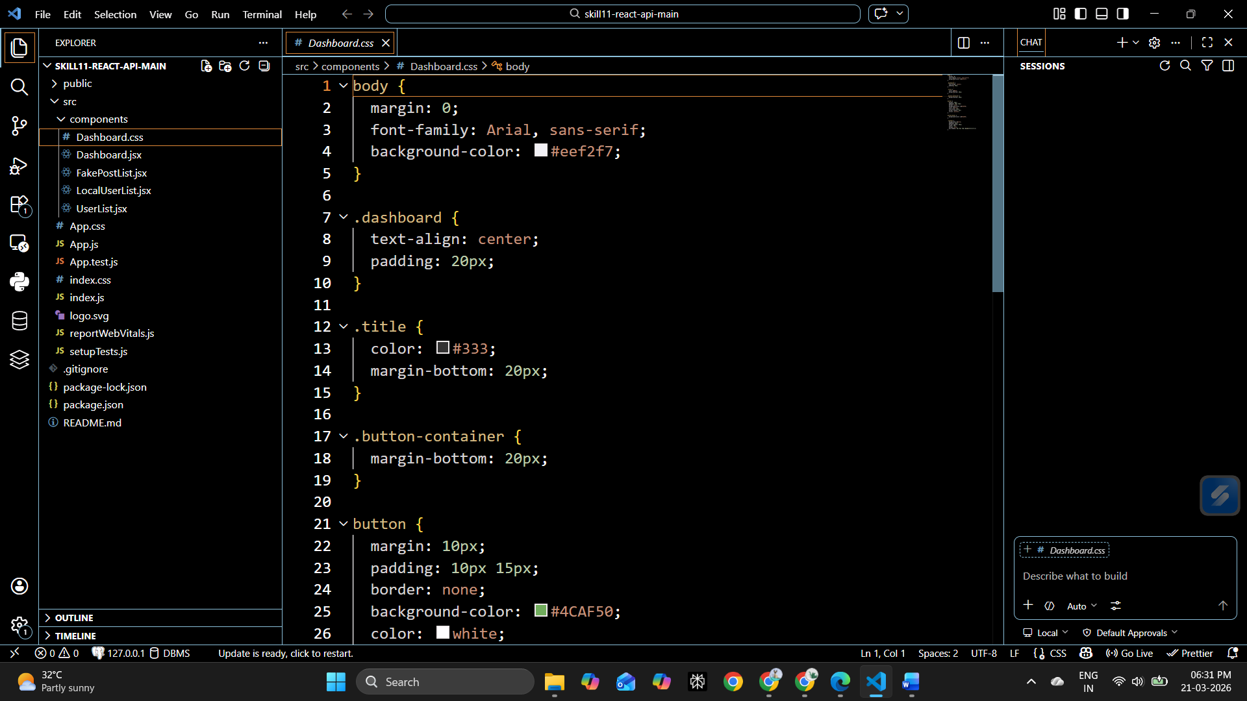
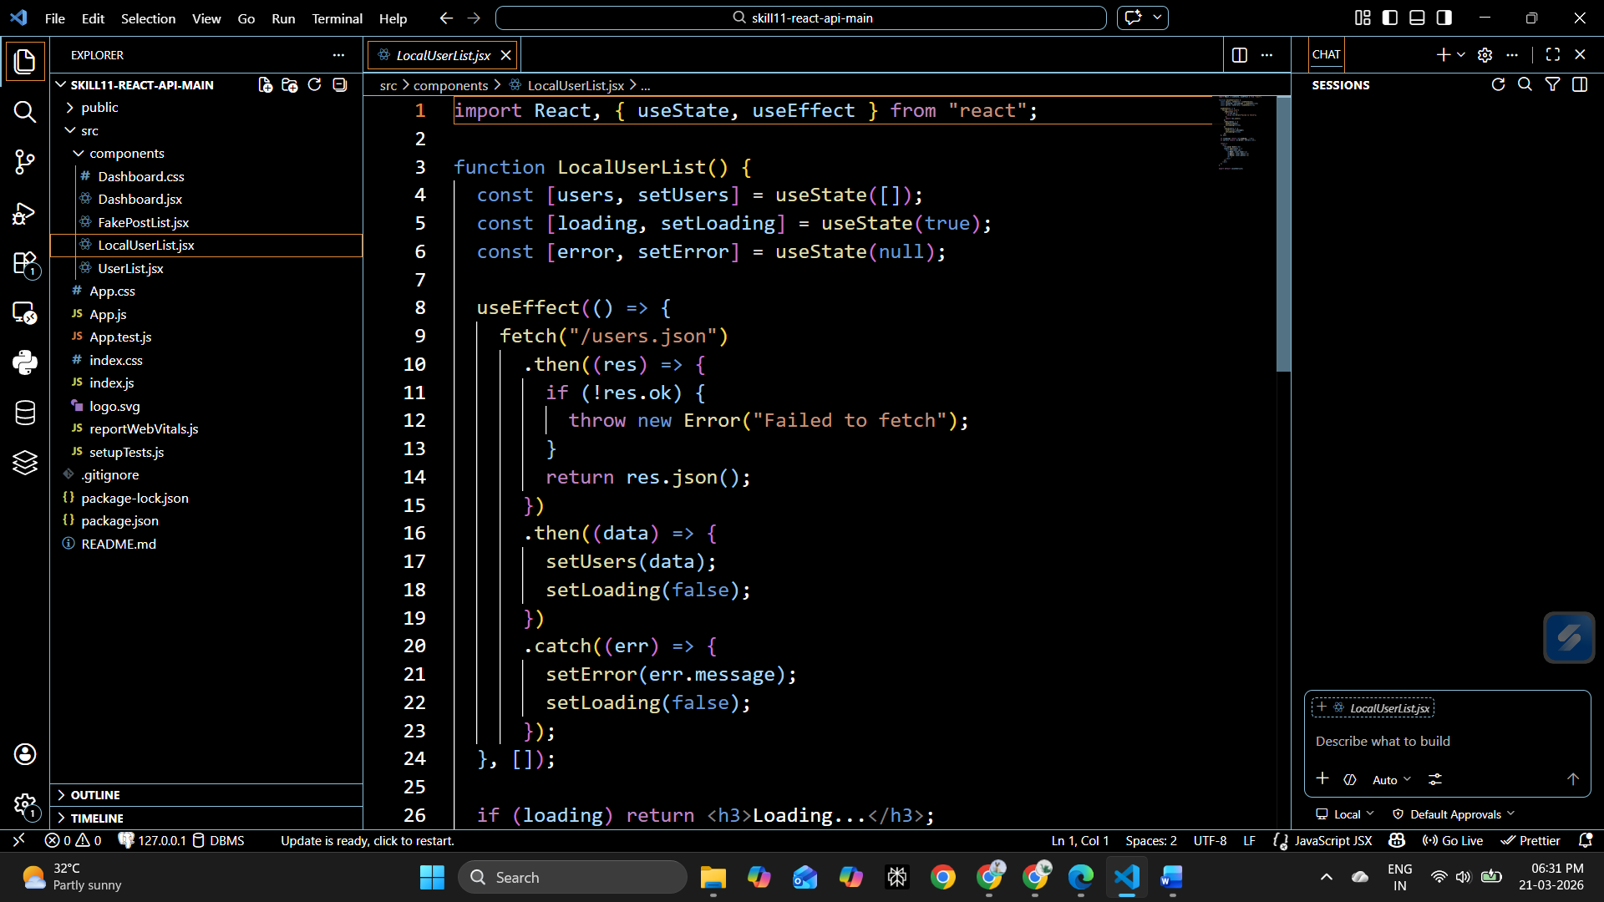
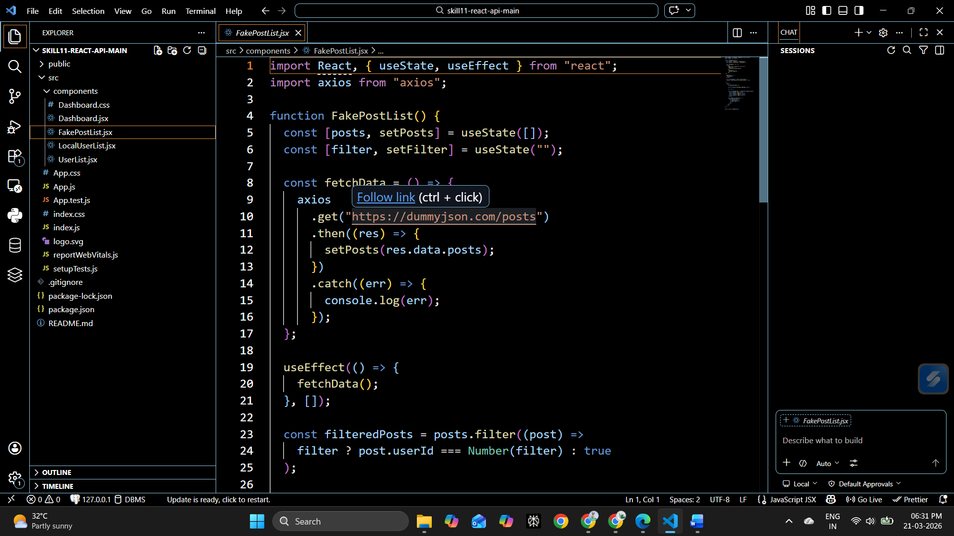

Output:

